PROJECT REPORT

Title of Project: Aesthetic Recipe Notebook
Name of the Innovator: Aysha Farshana S S
Start Date: 25-11-2025
End Date: 02-12-2025

Day 1: Empathise & Define
Step 1: Understanding the Need
- Which problem am I trying to solve?
People struggle to find simple, aesthetic, globally inspired recipes in one place. They want a clean, minimal, girly website that gives quick recipes without messy instructions.
- Who is affected by this problem?
- How did I find out about this? [Select whichever is applicable]
- Interviews
- Observation
- Online Research
- AI Tools
Step 2: What is the problem?
People want simple, aesthetic recipes with clear steps.
Users search for global snack ideas but most websites are cluttered or complicated.
Aesthetic and minimal recipe platforms are rare, especially for beginners.

How did I find out about this?
☑ Online Research
☑ AI Tools
☑ Observation
_______________________________________________________________________________
Why is this problem important to solve?
I am ideating a solution for users who find it difficult to perform and understand data analytics due to limited technical knowledge and lack of automation tools.
_________________________________________________________________________________
Take-home task
Many users said it’s hard to find simple and aesthetic recipes in one clean website.
Many users said it’s hard to find simple and aesthetic recipes in one clean website.
Some suggested adding clear categories like sweet, spicy, and drinks.
A few recommended including tiny cultural notes for each recipe to make it more engaging.

AI Tools you can use for Step 1 and 2:
- ChatGPT: Used for understanding user needs and food trends.
- Perplexity AI: Used for researching recipe patterns and user preferences.

Day 2: Ideate
Step 3:
Build a website that gives aesthetic, easy-to-follow recipes with clean layouts and pastel visuals.
Create a recipe platform that categorizes snacks by taste, country, and aesthetic mood for faster browsing.
Build an AI tool that suggests recipes based on ingredients the user already has.
Create an assistant that explains cultural background, taste profile, and cooking tips for each recipe.
Develop a mobile-friendly recipe notebook that shows quick global snack ideas with minimal steps.
List at least 5 different solutions (wild or realistic):
- Aesthetic Recipe Notebook – A girly website where users browse global snack recipes with pastel visuals and simple steps.
- Auto-Ingredient Matcher – Users upload what ingredients they have, and the tool suggests recipes.
- Mood-Based Recipe Finder – Choose mood (cozy, aesthetic, minimal, sweet) and get matching recipes.
- Animated Outfit + Recipe Pairing – Tool suggests outfits + recipes for occasions like college, work, or date night.
- Snack Explorer Wheel – A spinning wheel that gives random global snack ideas with cute animations.
Step 4: My favourite solution:
My favourite solution is the Aesthetic Recipe Notebook, a website that gives simple, aesthetic recipes with soft colors and minimal design for beginners and cooking lovers.
Step 5: Why am I choosing this solution?
I am choosing this solution because users love visually pleasing recipe pages that are clean and easy to follow. This solution makes cooking look aesthetic and enjoyable. It also helps beginners explore global snack ideas quickly without scrolling endless blogs.

Take-home task
Attach the image in this box below:
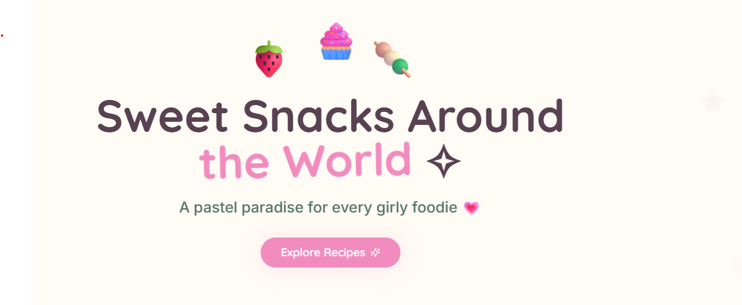
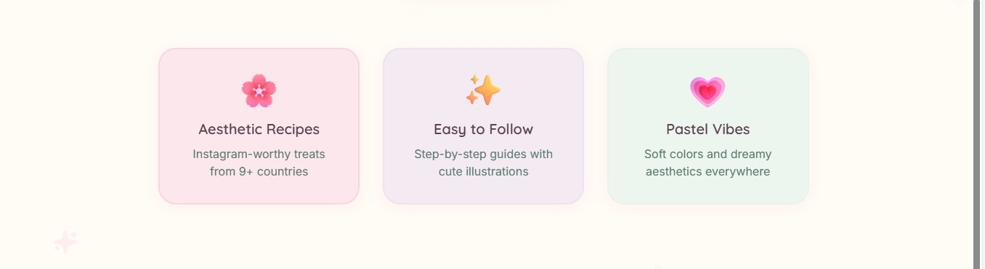
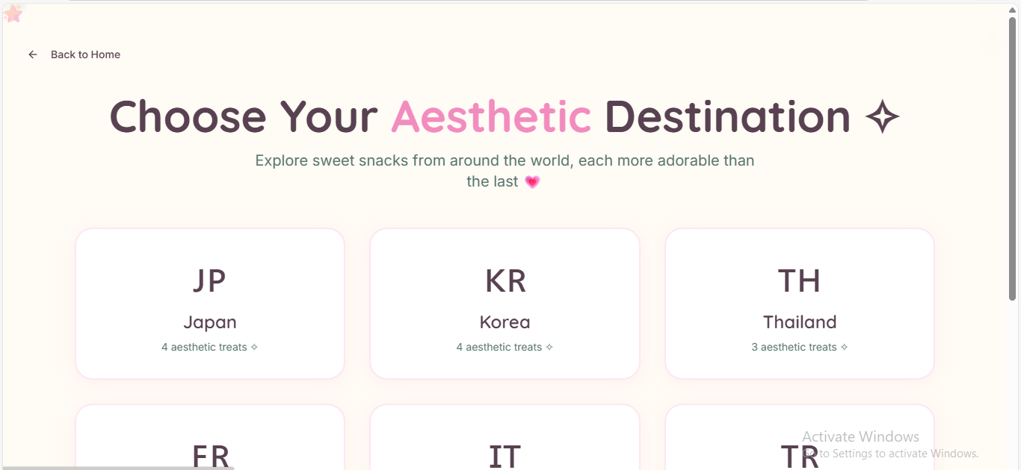
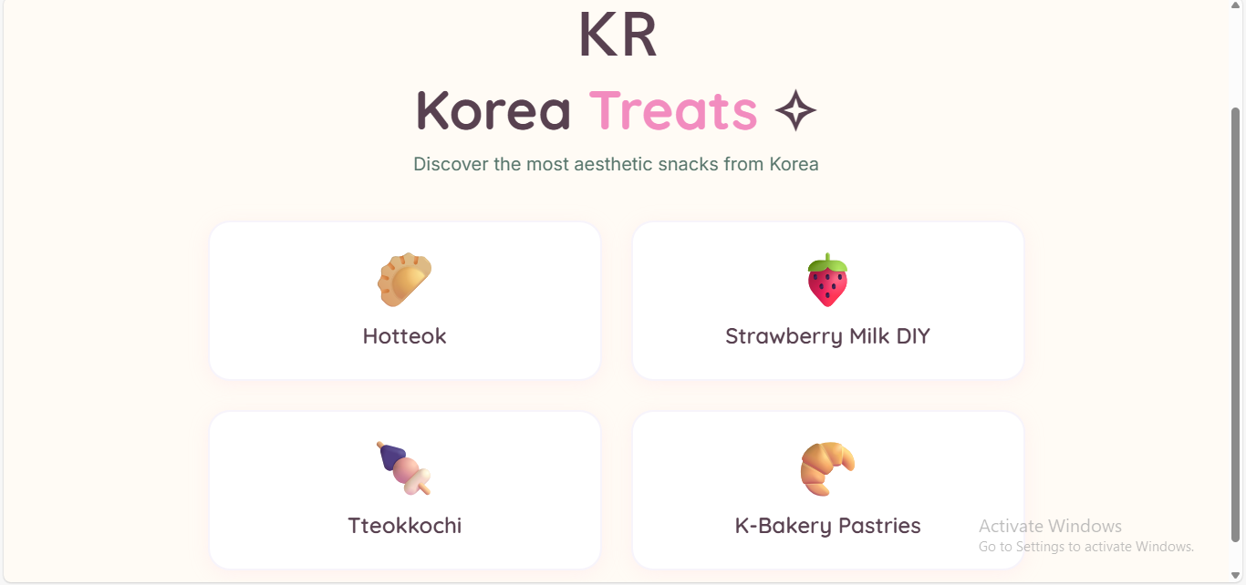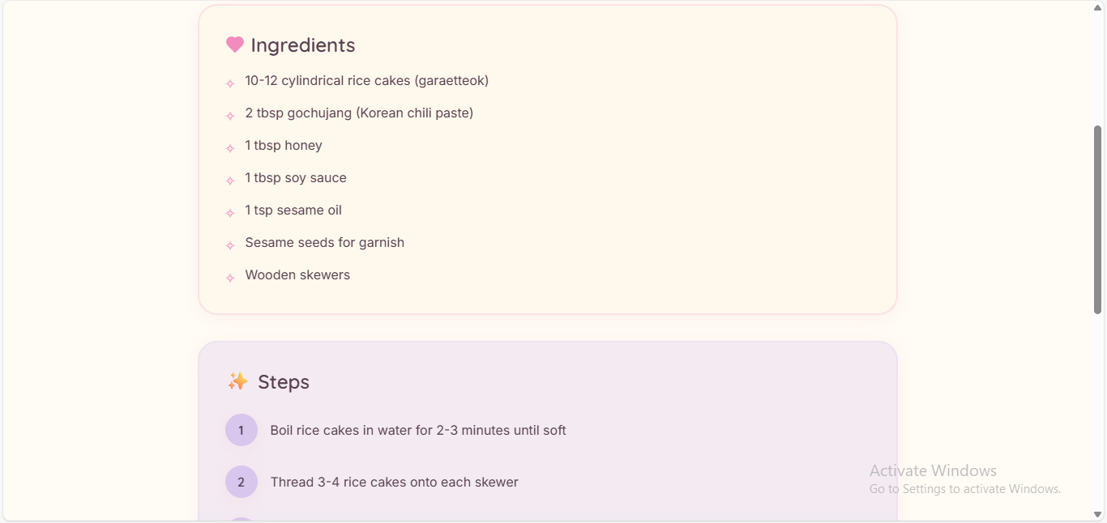

AI Tools you can use for Step 3-5:
ChatGPT/Perplexity AI: For comparing ideas and selecting the best one.
AI Tools you can use for the take-home task:
Canva AI/CoPilot AI/Meta AI: For creating design mockups.

Day 3: Prototype & Test
Step 6: Prototype – Building my first version
- What will my solution look like?
A pastel-themed website where users can view snack recipes with:
- Aesthetic images
- Clean ingredient lists
- Step-by-step instructions
- World recipes displayed in a scrapbook-style layout
_________________________________________________________________________________
- What AI tools will I need to build this?
AI Tools I will use:
AI Tools I finally selected to build this solution:
✅ ChatGPT – Used for generating insights, summaries, and writing explanations for the analyze data.
✅ Lovable AI – Used to design and develop the website interface quickly with AI support for coding and layout creation.
What AI tools I finally selected to build this solution?
- ChatGPT – For generating insights, explanations, and summaries from data.
- Lovable AI – For designing and building the website easily using AI assistance.
- GitHub – For saving and sharing the final project online.
Step 7: Test – Getting Feedback
- My classmates and project mentor
- What feedback did I receive?
👍 What works well:
• Aesthetic UI
• Simple recipe steps

🔧 What needs improvement:
• Include more global snacks
• Improve mobile responsiveness

Take-home task
I recorded my project explanation and feedback as voice notes and uploaded them along with images and the website model on GitHub.
What I uploaded:
- Screenshot images of the web interface
- The main project files and code

AI Tools used for Step 6–7:
- ChatGPT: Helped in testing the project and improving explanations for analytics results.
- Lovable AI: Used to build and refine the website structure.
- Canva AI: Used to design mock-ups and visuals for the project presentation.
Day 4: Showcase
Step 8: Presenting my Innovation
- Final Project Title: Aesthetic Recipe Notebook
- Document key points of my presentation:

Problem:
Lack of clean, aesthetic recipe platforms

Solution:

A pastel-themed recipe website

Features:

Simple steps, global snacks, girly aesthetic design

Tools Used:

ChatGPT, Lovable AI, Canva AI

Outcome:

A working recipe website with clear navigation and visuals

Impact:
Helps beginners discover aesthetic cooking easily.

Step 9: Reflections
- What did I enjoy the most during this project-based learning activity?
I enjoyed designing the aesthetic layout and creating minimal recipe pages. Building the soft, girly UI and seeing the website come alive with images and pastel colours was the best part.
________________________________________________________________________________
- What was my biggest challenge during this project-based learning activity?
My biggest challenge was organizing recipe categories and making the design clean on all devices. I also faced difficulty aligning UI elements perfectly, but practicing with AI tools helped me solve it.

GITHUB: https://github.com/AyshaFarshana/IBM-Project.git
PROJECT: https://sweet-aesthetic-bites.lovable.app

